**Waffle Chart in Tableau**

**Definition:**

Waffle chart is a 10 X 10 cell grid in which each cell represents 1 percentage point summing up to total 100%. Waffle chart can be represented as per the conditional formatting where cells are shown highlighted with different colors based on the percentage value of that KPI.

There are following used cases of Waffles chart:

+ To see high level view of items and their contribution to whole

+ Showing different KPI’s percentage value

Although we can notice that the use cases of Waffle chart are similar to the Donut chart but, Waffle chart represents the 0-100% KPI attainment or overall percentage value in more visually appealing way.

In this article I am going to mention the steps that required to build Waffle chart in tableau

**Objective:**

Let consider our objective is to build a Waffle chart to show the overall percentage sales of South and West regions together.

This is how the Waffle chart will look like:

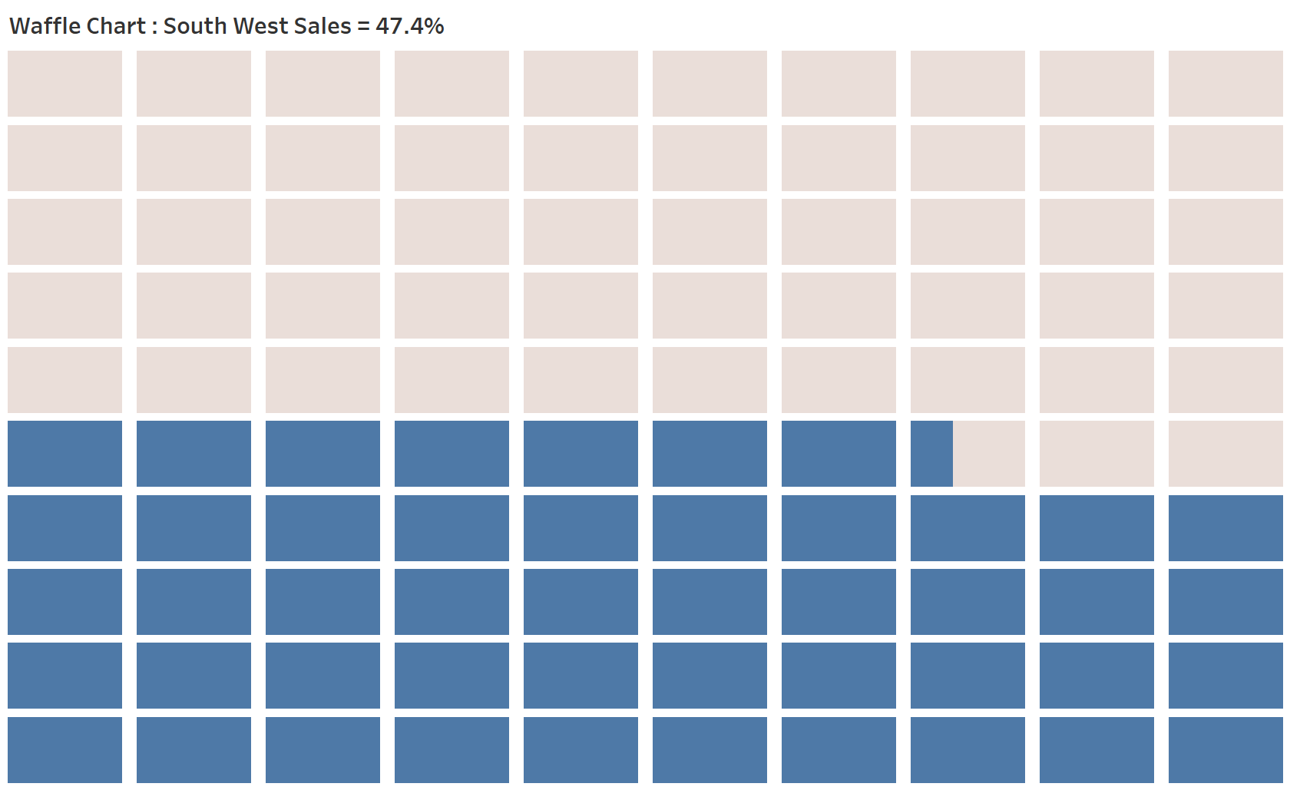

**Pre-requisites for data sources:**

To create Waffle chart, we are going to use two different data sources:

1. *“Waffle Chart Data.csv”:* This dataset is used to build the base of 10 X 10 cells grid. In this data set we have following two fields:

* *Columns:* This field contains value from 1 to 10
* *Rows:* For each *“Column”* value, this field contains value from 1 to 10

Thus, this results in total 100 rows of dataset

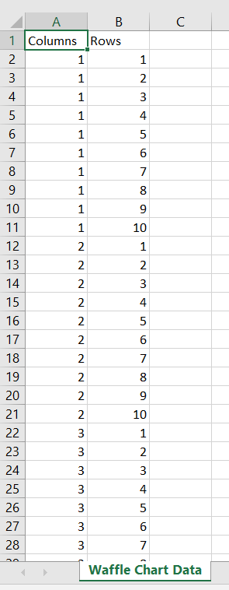

1. *“Sample – Superstore”:* It is the in-built tableau data source. This data source is used to get the total percentage of sales of South and West regions.

**Steps:**

Following are the steps:

1. Connect to both *“Waffle Chart Data.csv”* and *“Sample – Superstore”* data sources. For reference purpose data is attached along with this article
2. Go to Sheet1:

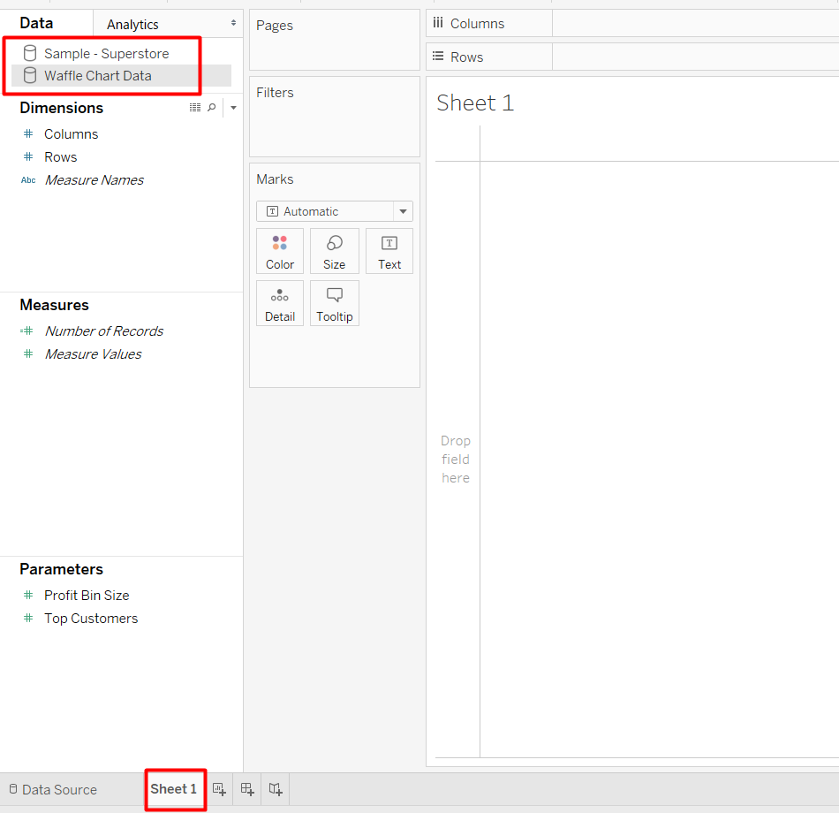

1. Select *“Waffle Chart Data”* data source and do the following:

+ drag “Columns” field to *Columns* shelf

+ drag “Rows” field to *Rows* shelf

+ Change chart type from “Automatic” to “Bar” in *Marks* card

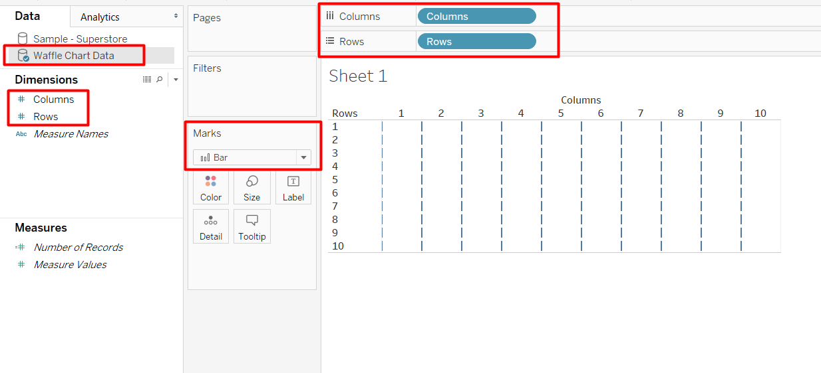

1. Select “*Sample – Superstore*” data source and create a calculation to get the value of “South” and “West” region’s sales as a percentage of overall regions sales**:**

*South West Sales =**SUM(IF [Region] = "South" OR [Region]= "West" THEN [Sales] END)/SUM([Sales])*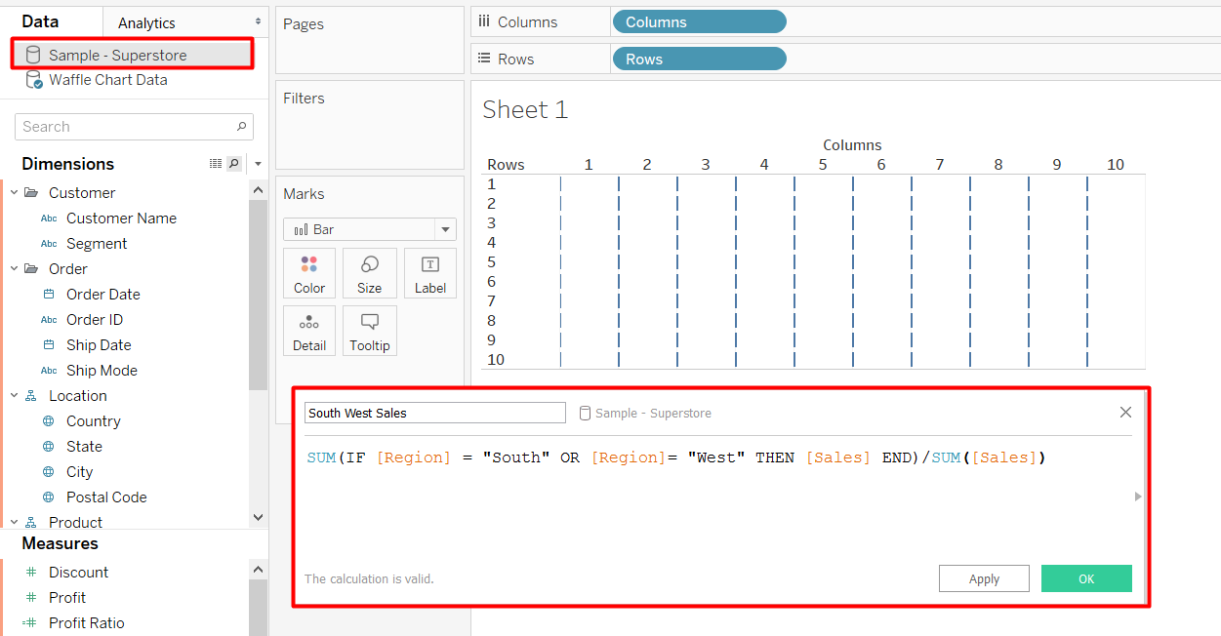

1. As a next step, we will select *“Waffle Chart Data”* data source and create following calculations:
2. *Shaded Portion*: This is calculated based on the percentage value of “*South West Sales”.* It is used to highlight the portion of 10 X 10 grid to represent “*South West Sales”* percentage

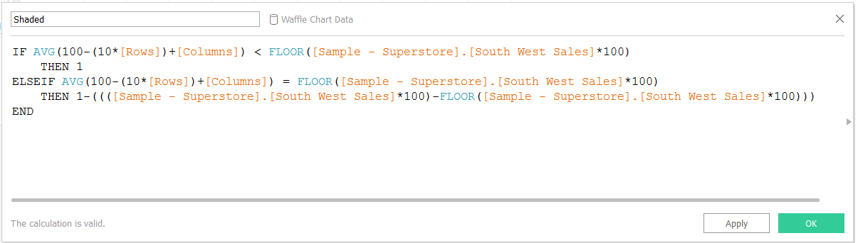

1. *Unshaded Portion*:It is used to highlight the remaining portion of 10 X 10 grid which is not covered by “*South West Sales”* value

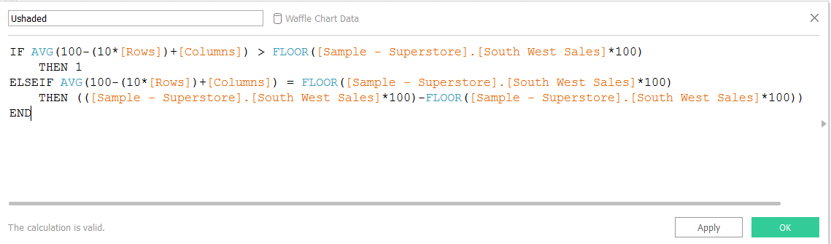

1. Now, bring the both “Shaded” and “Unshaded” calculated fields into the view by double-clicking on each field. Also, drag “Measure Names” in the “Color” *Marks* card

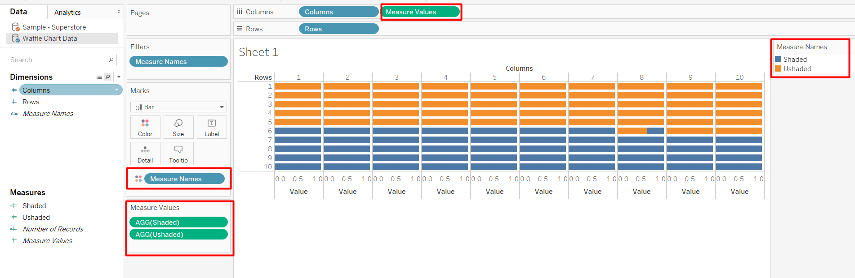

1. To make the chart visually more appealing, we can do following mentioned formatting changes:
2. hide the “Headers” by right-clicking on the header’s each axis and deselecting *“Show Header”* option

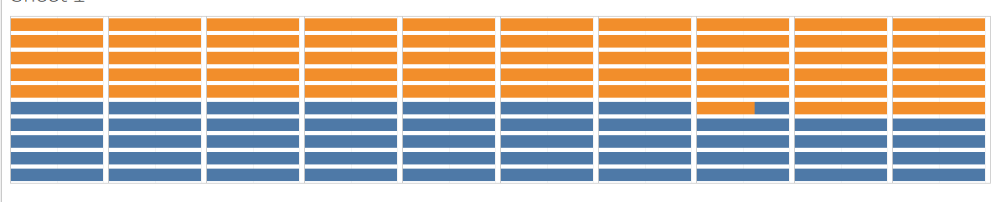

1. change the view of the chart as *“Entire View”*

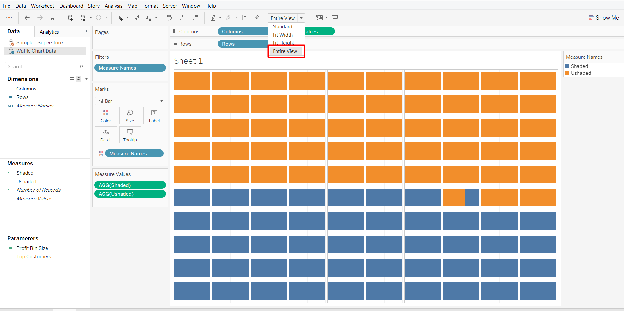

1. change the color of the legends:

+ “Shaded” in blue color to show the percentage attainment

+ “Unshaded” in light background color to show the remaining portion

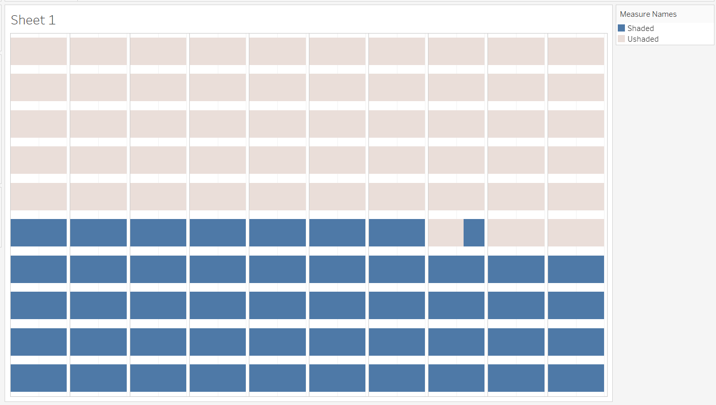

1. As the last step we will change the chart title to provide the required information about the chart. Finally, the Waffle chart will look like:

